**PROJECT DESIGN :** Solution Fit Template

**PHASE - 1**

**TEAM ID :** PNT2022TMID02471

**PROJECT TITLE :** IoT Based Smart Crop Protection

System for Agriculture

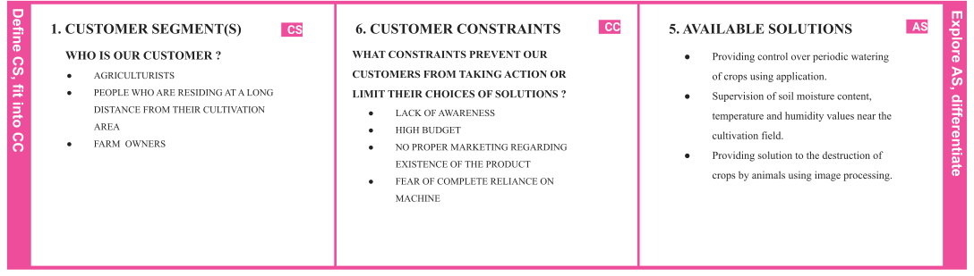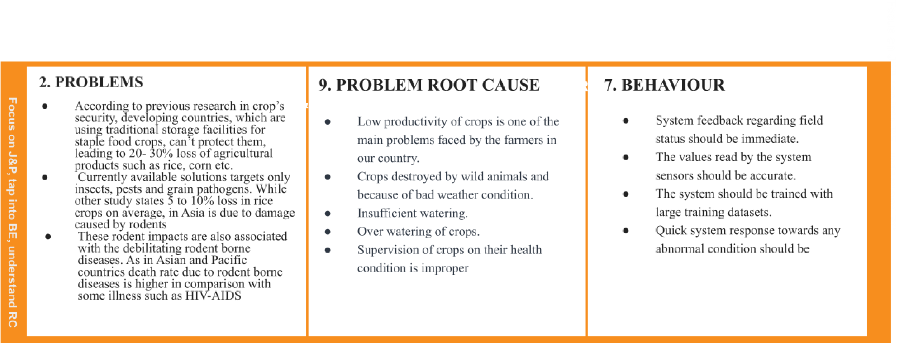

|  |  |  |  |  |  |  |
| --- | --- | --- | --- | --- | --- | --- |
|  | **I 3. T d** ● **e n**  **t** ● **i** ●  **f**  **y** ● **s**  **t r**  **o** | **RIGGERS**  Reading about technological advancements through magazines and social media.  Food scarcity and financial losses. Huge time consumption on crop supervision. Labour requirement | **TR** | **10. YOUR SOLUTION SL**   * A device to detect the animals and birds using the   Clarifai service   * If any animal or bird is detected the image will be captured and stored in the IBM Cloud object storage. * It also generates an alarm and avoid animals from destroying the crop. * The image URL will be stored in the IBM Cloudant   DB service   * The device will also monitor the soil moisture levels, temperature, and humidity values and send them to the IBM IoT Platform. * The image will be retrieved from Object storage and displayed in the web application. * A web application is developed to visualise the soil moisture, temperature, and humidity values. * Users can also control the motors through web   applications | 1. **CHANNELS OF BEHAVIOUR CH**    1. **ONLINE**       * Queries can be posted regarding the controlling of the system in the official website.       * Chatbot customer service.       * Report complaints online on any malfunctioning of the system.    2. **OFFLINE**       * Periodic surveys regarding the condition/working of the system.       * Postal services to take action against written queries and suggestions.       * Service centres in possible locations for customer satisfaction.       * Manuals in all languages to guide the users with   operating steps. |  |
| **n**  **4. EMOTIONS: BEFORE / AFTER**  **g**  **T BEFORE: R**  **&** ● Low productivity.  **E** ● Fear of destruction of crops by wild animals.  **M** ● Supervision of crops was hectic.   * High requirement of human resources. * Fear of financial losses   **AFTER:**   * Increased crop productivity * Crop Security * Supervision of crop was easier * Low necessity of human resources * High profit due to high productivity | | **EM** |